1-load balancing

⚖️ What Is Load Balancing?
# Source: AI Source: Provided by: [Data Path: Persons Table -> ID Column: 1, Name_En Column: Motasem Essam] -> From: [ChatGPT] on [12/18/2025]
Load balancing is a networking and server management technique that distributes incoming traffic or workload across multiple servers or network paths to improve performance, reliability, and availability.

🧠 Simple Definition:
# Source: AI Source: Provided by: [Data Path: Persons Table -> ID Column: 1, Name_En Column: Motasem Essam] -> From: [ChatGPT] on [12/18/2025]
Load balancing ensures that no single device or server is overwhelmed by spreading requests across a group of resources (like servers, firewalls, or network links).

📦 Example Scenario:
# Source: AI Source: Provided by: [Data Path: Persons Table -> ID Column: 1, Name_En Column: Motasem Essam] -> From: [ChatGPT] on [12/18/2025]
Imagine a website that receives 10,000 visitors per minute.
Instead of one server handling all requests, a load balancer distributes them among 3 or more servers:
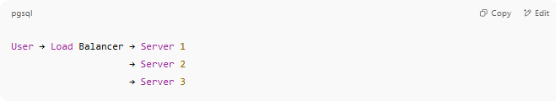
User → Load Balancer → Server 1
→ Server 2
→ Server 3

🔍 Why Load Balancing Matters
# Source: AI Source: Provided by: [Data Path: Persons Table -> ID Column: 1, Name_En Column: Motasem Essam] -> From: [ChatGPT] on [12/18/2025]
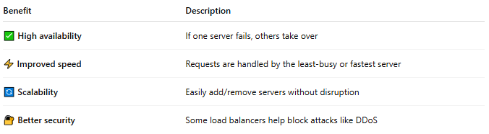

Benefit | Description
✅ High availability | If one server fails, others take over
⚡ Improved speed | Requests are handled by the least-busy or fastest server
🔄 Scalability | Easily add/remove servers without disruption
🔐 Better security | Some load balancers help block attacks like DDoS

🔢 Common Load Balancing Methods
# Source: AI Source: Provided by: [Data Path: Persons Table -> ID Column: 1, Name_En Column: Motasem Essam] -> From: [ChatGPT] on [12/18/2025]
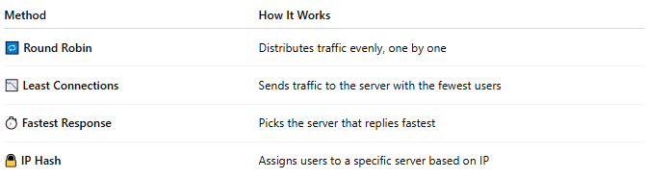

Method | How It Works
🔁 Round Robin | Distributes traffic evenly, one by one
📉 Least Connections | Sends traffic to the server with the fewest users
⏱ Fastest Response | Picks the server that replies fastest
🔒 IP Hash | Assigns users to a specific server based on IP

🧰 Types of Load Balancers
# Source: AI Source: Provided by: [Data Path: Persons Table -> ID Column: 1, Name_En Column: Motasem Essam] -> From: [ChatGPT] on [12/18/2025]
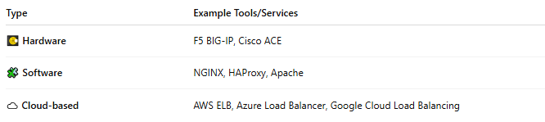

Type | Example Tools/Services
💽 Hardware | F5 BIG-IP, Cisco ACE
🧩 Software | NGINX, HAProxy, Apache
☁️ Cloud-based | AWS ELB, Azure Load Balancer, Google Cloud Load Balancing

📌 Summary
# Source: AI Source: Provided by: [Data Path: Persons Table -> ID Column: 1, Name_En Column: Motasem Essam] -> From: [ChatGPT] on [12/18/2025]
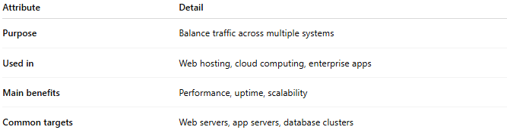

Attribute | Detail
Purpose | Balance traffic across multiple systems
Used in | Web hosting, cloud computing, enterprise apps
Main benefits | Performance, uptime, scalability
Common targets | Web servers, app servers, database clusters

2-Load Balancer

⚖️ What Is a Load Balancer?
# Source: AI Source: Provided by: [Data Path: Persons Table -> ID Column: 1, Name_En Column: Motasem Essam] -> From: [ChatGPT] on [12/18/2025]
A load balancer is a system (software or hardware) that distributes incoming traffic across multiple servers to ensure:
- ⚡ Fast performance
- 🔁 High availability
- 💥 Protection from overload

✅ Simple Definition:
# Source: AI Source: Provided by: [Data Path: Persons Table -> ID Column: 1, Name_En Column: Motasem Essam] -> From: [ChatGPT] on [12/18/2025]
A load balancer acts like a traffic controller for websites and apps.
It spreads user requests across multiple servers, so no single server gets overwhelmed.

🧠 Real-Life Analogy:
# Source: AI Source: Provided by: [Data Path: Persons Table -> ID Column: 1, Name_En Column: Motasem Essam] -> From: [ChatGPT] on [12/18/2025]
Think of a load balancer like a receptionist at a hospital:
- Patients (users) arrive randomly
- The receptionist assigns them to available doctors (servers)
- This keeps the workload balanced and reduces waiting time

load balancing and Load Balancer
# Source: AI Source: Provided by: [Data Path: Persons Table -> ID Column: 1, Name_En Column: Motasem Essam] -> From: [ChatGPT] on [12/18/2025]
Load balancing and a load balancer are related but not the same. Here’s the clear distinction:

Load Balancing (the concept)
# Source: AI Source: Provided by: [Data Path: Persons Table -> ID Column: 1, Name_En Column: Motasem Essam] -> From: [ChatGPT] on [12/18/2025]
Load balancing is the process or strategy of distributing incoming work (traffic, requests, jobs) across multiple resources to achieve:
- Better performance
- Higher availability
- Scalability
- Fault tolerance
It answers “what is being done?”
Examples of load-balancing strategies
- Round robin
- Least connections
- Weighted distribution
- Hash-based routing
- Geographic routing
Load balancing can be implemented at:
- Network level
- Application level
- Database level
- Even inside code (e.g., thread pools)

Load Balancer (the tool or system)
# Source: AI Source: Provided by: [Data Path: Persons Table -> ID Column: 1, Name_En Column: Motasem Essam] -> From: [ChatGPT] on [12/18/2025]
A load balancer is the actual component (software or hardware) that performs load balancing.
It answers “what is doing it?”
Types of load balancers
- Hardware: F5, Citrix ADC
- Software: NGINX, HAProxy, Envoy
- Cloud-managed: AWS ELB/ALB/NLB, Azure Load Balancer, GCP Load Balancing
What a load balancer does
- Receives client requests
- Applies load-balancing algorithms
- Routes traffic to healthy backend servers
- Performs health checks
- May handle SSL termination, caching, rate limiting

Side-by-side summary
# Source: AI Source: Provided by: [Data Path: Persons Table -> ID Column: 1, Name_En Column: Motasem Essam] -> From: [ChatGPT] on [12/18/2025]
Aspect | Load Balancing | Load Balancer
Nature | Concept / process | Tool / component
Focus | Strategy | Execution
Question answered | How traffic is distributed | What distributes traffic
Example | Round-robin traffic distribution | NGINX, AWS ALB

Simple analogy
# Source: AI Source: Provided by: [Data Path: Persons Table -> ID Column: 1, Name_En Column: Motasem Essam] -> From: [ChatGPT] on [12/18/2025]
- Load balancing → the method of dividing work
- Load balancer → the traffic cop that applies the method
If you want, I can also explain this in the context of web apps, microservices, or network layers (L4 vs L7).

A diagram of load balancer architecture
# Source: AI Source: Provided by: [Data Path: Persons Table -> ID Column: 1, Name_En Column: Motasem Essam] -> From: [ChatGPT] on [12/18/2025]
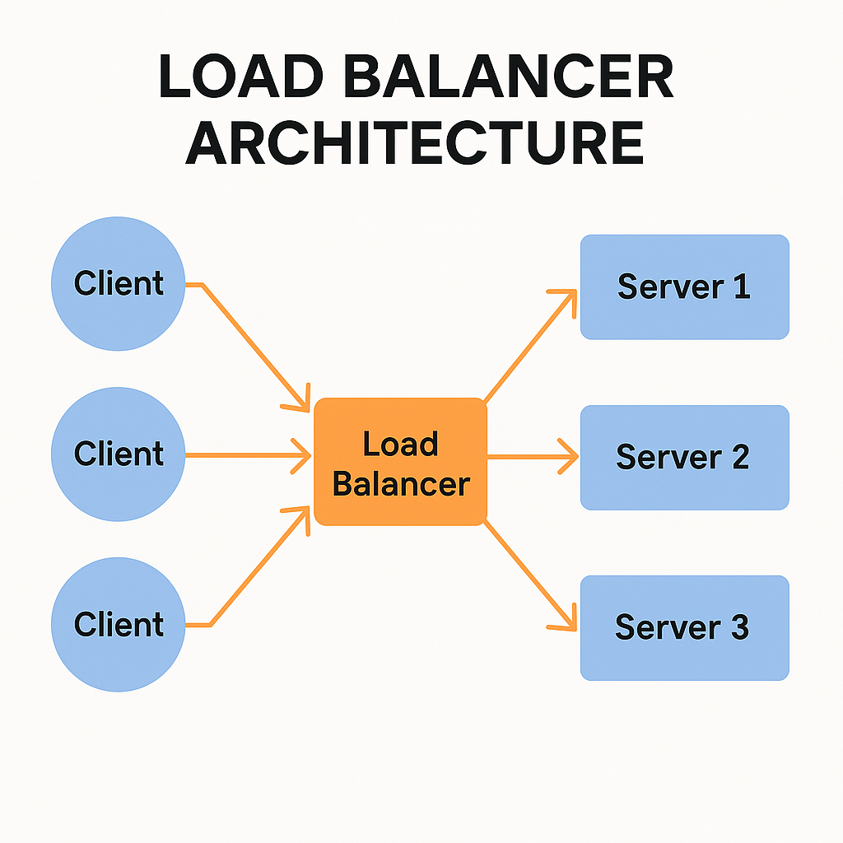

🛠️ What Load Balancers Do:
# Source: AI Source: Provided by: [Data Path: Persons Table -> ID Column: 1, Name_En Column: Motasem Essam] -> From: [ChatGPT] on [12/18/2025]
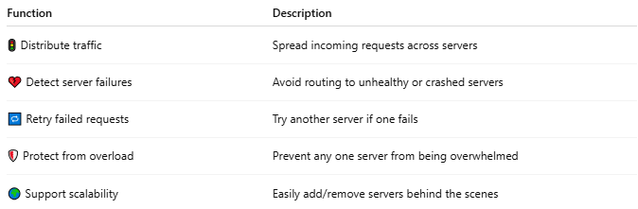

Function | Description
🚦 Distribute traffic | Spread incoming requests across servers
💔 Detect server failures | Avoid routing to unhealthy or crashed servers
🔁 Retry failed requests | Try another server if one fails
🛡 Protect from overload | Prevent any one server from being overwhelmed
🌍 Support scalability | Easily add/remove servers behind the scenes

🌐 Common Use Cases:
# Source: AI Source: Provided by: [Data Path: Persons Table -> ID Column: 1, Name_En Column: Motasem Essam] -> From: [ChatGPT] on [12/18/2025]
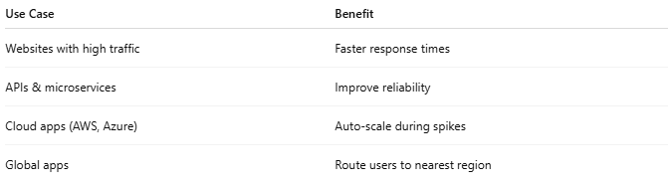

Use Case | Benefit
Websites with high traffic | Faster response times
APIs & microservices | Improve reliability
Cloud apps (AWS, Azure) | Auto-scale during spikes
Global apps | Route users to nearest region

⚙️ Types of Load Balancing Algorithms:
# Source: AI Source: Provided by: [Data Path: Persons Table -> ID Column: 1, Name_En Column: Motasem Essam] -> From: [ChatGPT] on [12/18/2025]
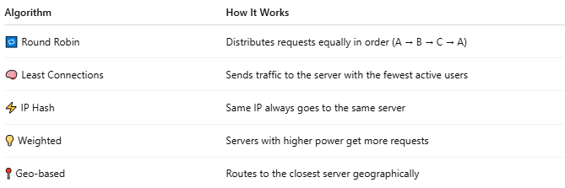

Algorithm | How It Works
🔁 Round Robin | Distributes requests equally in order (A → B → C → A)
🧠 Least Connections | Sends traffic to the server with the fewest active users
⚡ IP Hash | Same IP always goes to the same server
💡 Weighted | Servers with higher power get more requests
📍 Geo-based | Routes to the closest server geographically

🧪 Example in Action:
# Source: AI Source: Provided by: [Data Path: Persons Table -> ID Column: 1, Name_En Column: Motasem Essam] -> From: [ChatGPT] on [12/18/2025]
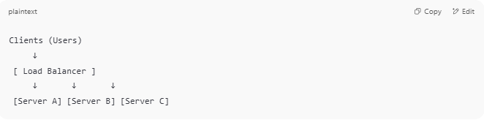

Clients (Users)
↓
[ Load Balancer ]
↓ ↓ ↓
[Server A] [Server B] [Server C]

🧰 Popular Load Balancers
# Source: AI Source: Provided by: [Data Path: Persons Table -> ID Column: 1, Name_En Column: Motasem Essam] -> From: [ChatGPT] on [12/18/2025]
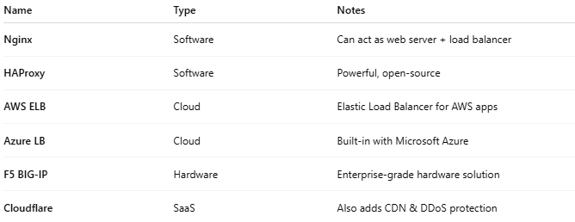

Name | Type | Notes
Nginx | Software | Can act as web server + load balancer
HAProxy | Software | Powerful, open-source
AWS ELB | Cloud | Elastic Load Balancer for AWS apps
Azure LB | Cloud | Built-in with Microsoft Azure
F5 BIG-IP | Hardware | Enterprise-grade hardware solution
Cloudflare | SaaS | Also adds CDN & DDoS protection

🔐 Load Balancer Security Benefits
# Source: AI Source: Provided by: [Data Path: Persons Table -> ID Column: 1, Name_En Column: Motasem Essam] -> From: [ChatGPT] on [12/18/2025]
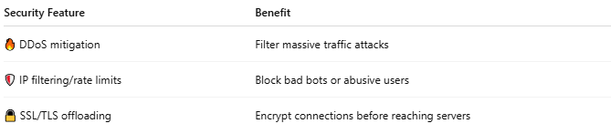

Security Feature | Benefit
🔥 DDoS mitigation | Filter massive traffic attacks
🛡 IP filtering/rate limits | Block bad bots or abusive users
🔒 SSL/TLS offloading | Encrypt connections before reaching servers

🆚 Load Balancer vs Proxy
# Source: AI Source: Provided by: [Data Path: Persons Table -> ID Column: 1, Name_En Column: Motasem Essam] -> From: [ChatGPT] on [12/18/2025]
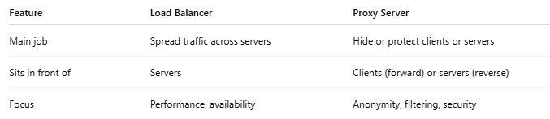

Feature | Load Balancer | Proxy Server
Main job | Spread traffic across servers | Hide or protect clients or servers
Sits in front of | Servers | Clients (forward) or servers (reverse)
Focus | Performance, availability | Anonymity, filtering, security

📌 Summary
# Source: AI Source: Provided by: [Data Path: Persons Table -> ID Column: 1, Name_En Column: Motasem Essam] -> From: [ChatGPT] on [12/18/2025]
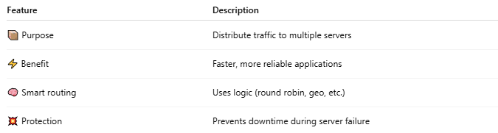

Feature | Description
📦 Purpose | Distribute traffic to multiple servers
⚡ Benefit | Faster, more reliable applications
🧠 Smart routing | Uses logic (round robin, geo, etc.)
💥 Protection | Prevents downtime during server failure

